REMEMBERING CORNER GREEN.
Good evening ladies and gentlemen. This evenings talk is about an often forgotten part of Collyweston, Corner Green. For those of you who are unfamiliar with it, this settlement used to stand beside the A47 a hundred yards or so to the south of Cuckoo Lodge, a former toll house. Travelling from the Collyweston Slater, head east along The Drove, turn right onto the A47, pass the English Nature pound on your left and Corner Green is on the left about 100 yards towards Duddington, it is now part of the quarry. (slide one)
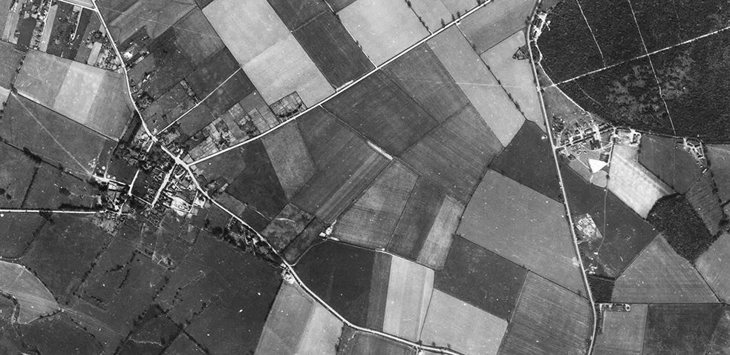
Cuckoo Lodge

Corner Green

The Drove

Collyweston

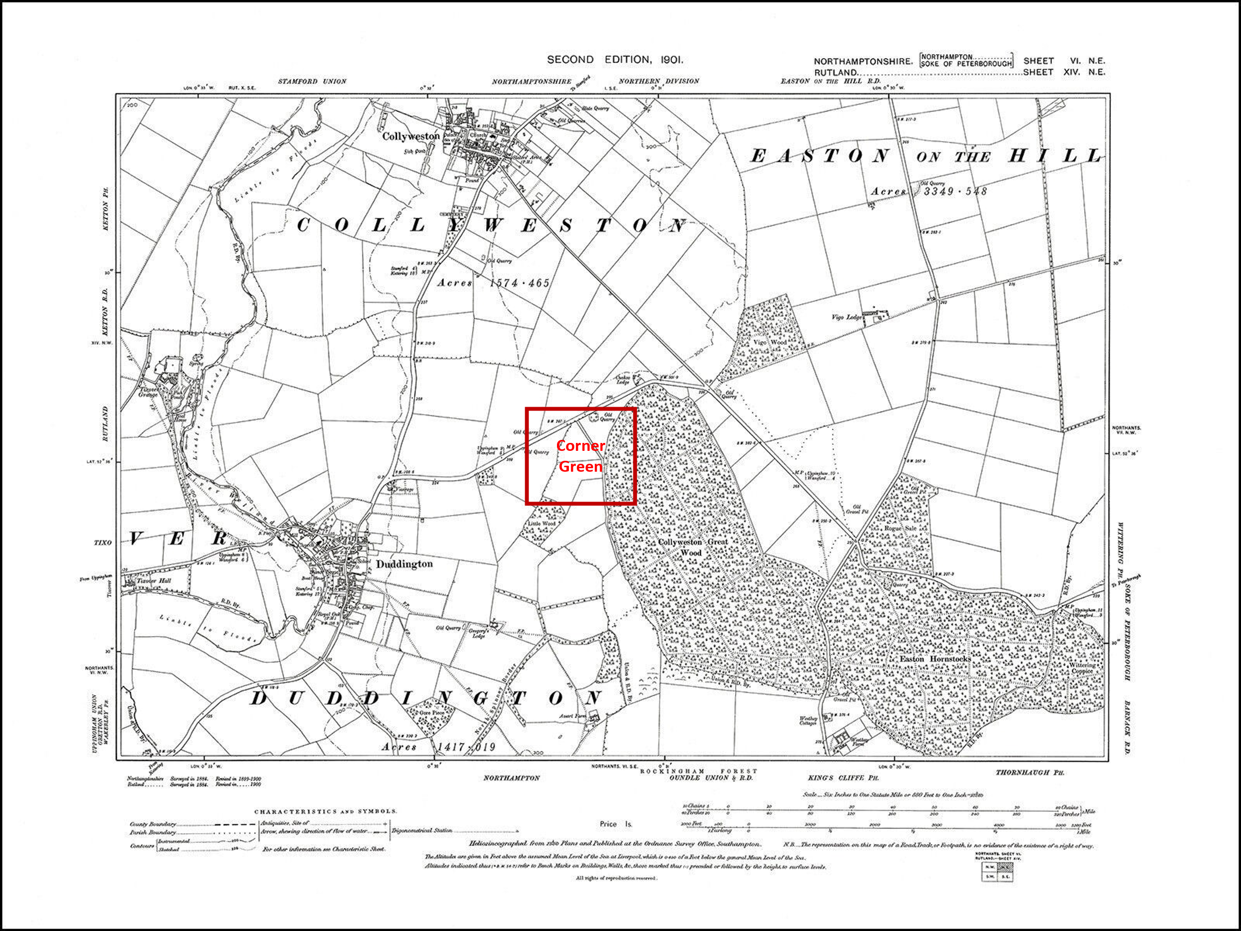
So by way of an introduction let me give you a little background about the village for those of you who are new to our village or unfamiliar with the area. At the time of the Domesday Book in 1087 Collyweston was simply known as Weston. A former Lord of the Manor in the 13/14th century, Nicholas de Seagrave, changed its name to Colyn’s Weston during his Lordship and over time this became Collyweston. The Colly part is derived from Colin, COL being a shortform for Nicholas.
Tonight we are concentrating on a little known area of the village, just off the A47 called Corner Green. The earliest record of the area, formerly known as CornWELL Greene, is in 1082 when Collyweston had approximately 60 acres of woodland belonging to the manor. This is stated as being in the southern tip of the ‘township’/village where the woodland survives today as Collyweston Great Wood, mainly on clay with former heath on limestone to its north. The township of Collyweston was incorporated within the bounds of Rockingham Forest by the early 13th century, but in 1229 it was excluded. A wood known as ‘Weston’ was recorded in 1287 as lying at the south of the village next to Rockingham Forest woods and in the survey of 1628 the woodland amounted to 320 acres. On screen is the earliest map being the Cliffe bailiwick map circa 1640 which shows the woodland and the village of Collyweston on the very top edge with Collyweston Wood just below it.
Cliffe bailiwick map c1640 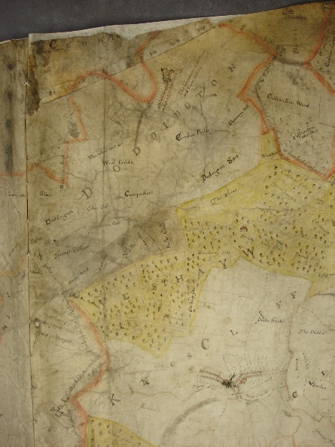
In Lady Margaret’s household accounts of 1505 there is a reference to the sale of bark, suggesting that they were harvesting wood from Collyweston Great wood and selling bark for rope making, the Corner Green area gives easy access to the woodland with space for the storage of felled trees etc. An old map of the village shows another road spurring off The Drove, travelling behind ‘Cuckoo’ Lodge and direct to Corner Green. There is also reference to West Hay so Lady Margaret’s household were clearly familiar with the site.
Hunting was a significant pastime in the late medieval and Tudor period and, like all royalty and nobles of the period, Margaret Beaufort and her son Henry VII, enjoyed hunting and frequently rode together; Margaret had given strict orders that her Park at Collyweston should be kept full of stock for the King’s pleasure. Later Henry VIII became hunting greatest proponent, making regular visits to the forest for the sport. His illegitimate son, Henry Fitzroy, also enjoyed hunting and is reported to have accompanied David Cecil on a hunt and it was afterwards proudly recorded that the six year old Fitzroy had ‘killed a buck’ himself!
David Cecil was an early member of the Burghley dynasty and was at one time a Ward of Lady Margaret’s and was under the supervision of Sir David Phillips. You may be interested to know that, David Phillips is buried in the north Chapel at St Mary’s Church in Stamford, his tomb paid for by Lady Margaret is emblazoned with Tudor iconography. Cecil eventually became keeper of the park and steward at Collyweston.
Later Village gentry, i.e. the Heath family and the Tryons no doubt also took part in the sport of hunting and would have been frequent visitors to the woodland.
So far as we have been able to discover the area called Cornwell Green made its first appearance in the historical records around 1645, when it was claimed by Duddington as part of West Hay, but it was ultimately adjudged to belong to Collyweston.
Thomas Markham of Duddington said that for 40 years his father was Woodward to the Earl of Exeter, and cut thorns and bushes on the green to use for fences around the woods and carried some back to Burghley. (NROSG140). This claim was dismissed in favour of Robert Heath.
Slides 5 to 9 Heath’s response to claims and other correspondence concerning the maypole
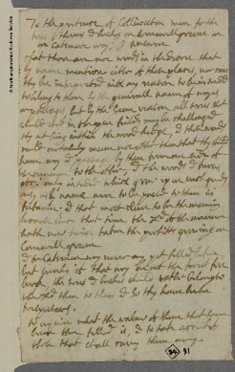 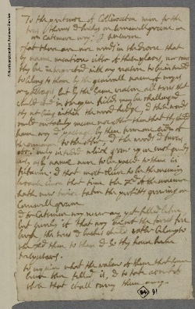
Heath’s Park
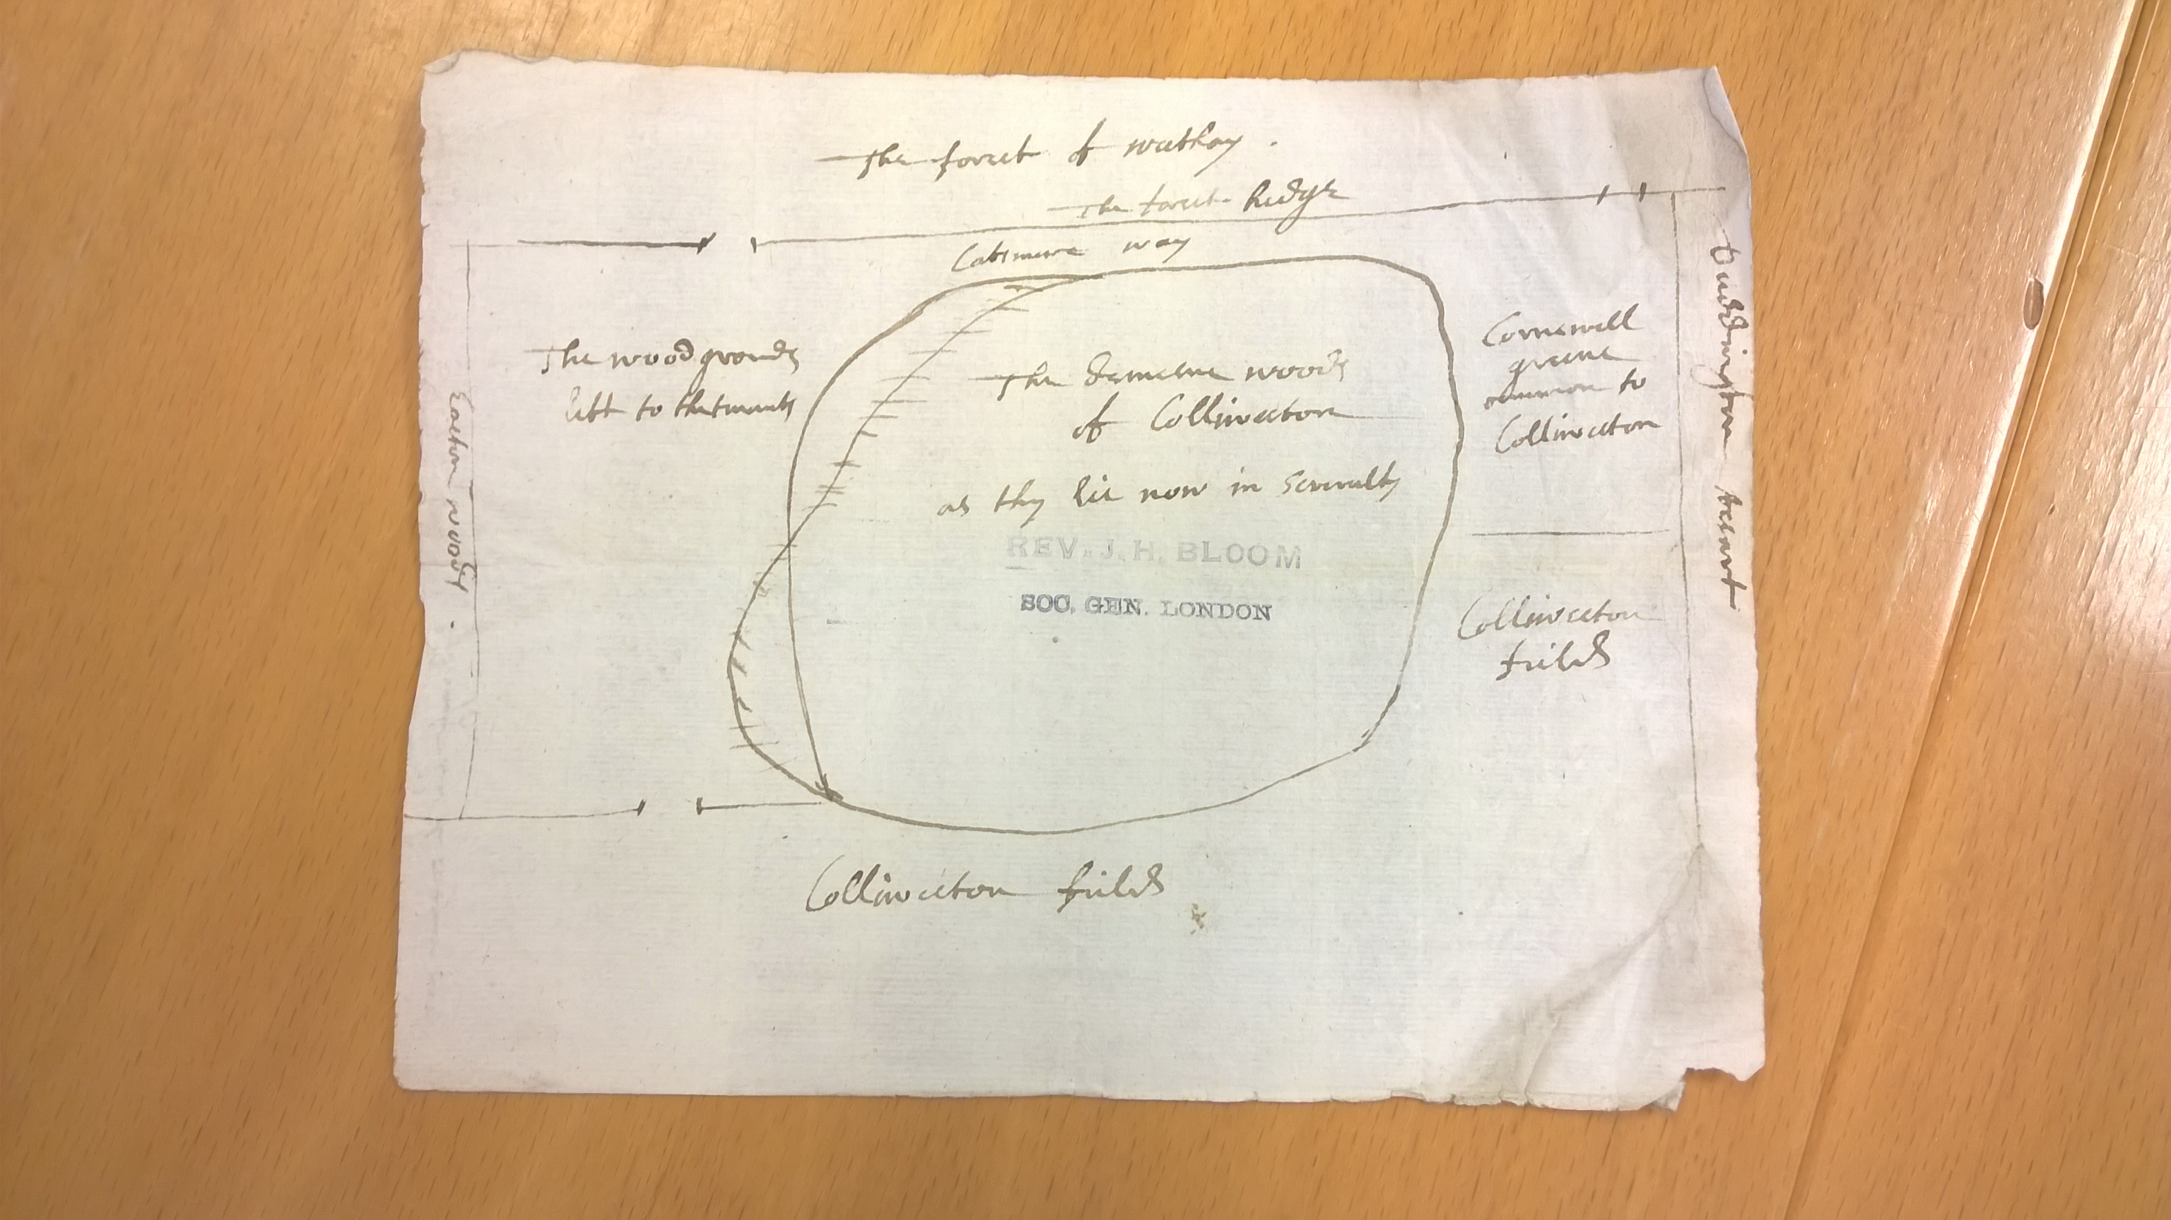
In approximately 1640 when the Village was under the custodianship of Sir Robert Heath and his son Sir Edward Heath, a petition was made by Sir Robert to extend the boundary of Collyweston Park as it was considered too small to accommodate the ever-growing desire to breed and hunt deer. The sketch map shows the boundary, note Cornwell Green is mentioned, also the A47 is called Cottesmore Way (presumably because Sir Edward and his family lived at Cottesmore??!) This highlights the power of the former owners of the village.
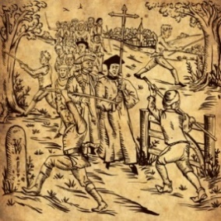
During the occupation of the Heaths the villagers often came to blows with the residents of King’s Cliffe regarding the boundary between the two villages and have been reported as moving the ‘Mere Stones’ i.e. boundary markers. There is a rather charming story held by Northamptonshire Archives telling the story of the villagers visiting the ‘service tree’ (of which there are now 4) and also cutting a May Pole for which they seem to have paid £15 to the Lord of the Manor.
Another story is that the villagers would ‘beat the bounds”. On the evening of Ascension Day a group from every parish and various governing bodies in England would walk around the perimeters of their land. Each boundary post would be beaten with sticks to mark it out in the minds of the younger generations, to deter trespassers and the clergy would pray for the land along the way, in some areas a young boy was literally beaten against the trees, presumably to make sure he knew exactly where the boundary lay!! It may have been on these occasions when the dispute flared up with neighbouring King’s Cliffe and the ‘sticks’ used for beating were used as a weapon against their neighbours.
On a recent visit to the woods we came across evidence of its former residents, i.e. an old bedstead and a mangle!
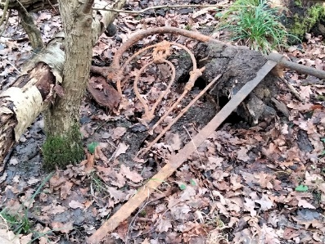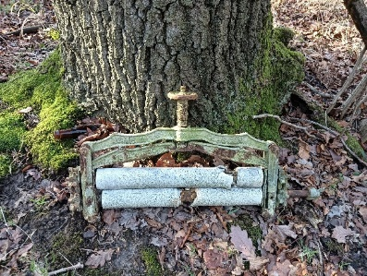
All remained fairly quiet at Corner Green following the purchase of Collyweston Manor by Lord Brownlow in 1777, when he paid the Tryon family the grand sum of £22,200 for the village and accompanying lands.
Regrettably we have not found any records of what happened to the area during this time, it would seem that Brownlow also enjoyed hunting, Burghley apparently had 4 Hunting Lodges in the woodland. We know from a local resident that Cuckoo Lodge was built by the Burghley Estate, originally as a Toll House, it later became the Game Keeper’s Lodge. There are some records reporting the sale of wood from Collyweston Great Wood. As previously mentioned until relatively recently bark from the lime trees was used for rope making and subsequently large quantities of trees were felled, stripped and the bark shipped to Wisbech down the River Nene to be made into rope.
The next reference we have is the tithe map of the 1840’s showing pastures called Cow Wood and Corner Green lying east and west of Collyweston Great Wood. (NRO T169). In the supporting documentation for the tithe map two gentlemen are mentioned as renting grass land at Corner Green, one Harrington held 6 acres 15 perches of land for 11 shillings and 4 pence and James Hiles? held 8 acres 24 perches for 19 shillings and 4 pence, about 2 shillings per acre or 10p!!
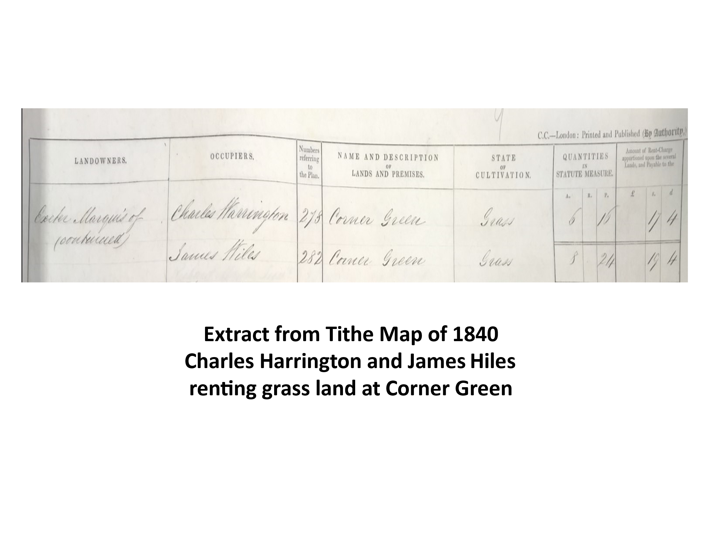
We also have some records kindly provided by Tim Starsmore-Sutton of Natural England concerning the sale of wood and payments made to various villagers by the Bailiff/Woodward for services rendered for the disposal of ‘vermin’ within the wood, these are available for you to view after the talk. You will see there are some familiar local names included. Needless to say Sandra’s family
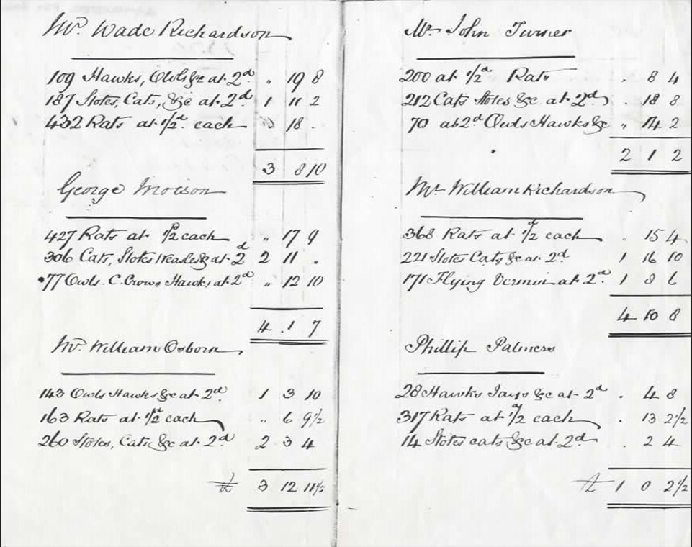
(the Osbornes) feature in the Gamekeeper’s Pay Book, you will see William (her great Grandfather) was paid £3 12s 11 halfpenny for disposing of the vermin, including 143 owls and hawks, 163 rats (at a halfpenny each) and 260 stoats, cats etc. For those who live in the village you may notice also that one of those paid for disposing of vermin was Mr Philip Palmer, could he be related to our current gamekeeper, also Philip Palmer who now lives in Duddington!
The next major event for what we now know as Corner Green, was during the second world war when prefabs were built to house German Prisoners of War. Falling within the boundary of Northamptonshire, Corner Green became a satellite ‘CAMP’ to the main Prisoner of War Camp at Weekley. HOWEVER, it seems that an inspector wasn’t particularly impressed with the Germany Prisoners stating that on his visit on 29th January 1948 just prior to the site being decommissioned.
“the PSoW’s of this hostel work in a brick factory. They work in two shifts so that only one half of the strength is in the camp at a time. This is one of the few camps which would appreciate lectures on Sundays as on Sunday the whole camp is in”.
The inspector gave two lectures at Collyweston. One at 1400 hours to the night workers and one at 1900 hours to the day shift.
The first of these lectures was on the Jewish question, the second on the Political Development in Germany. The Lecturer states that “Whilst the questions after the first lecture were quite sensible and nothing out of the ordinary was asked, the discussion after the second lecture proved that this camp was definitely not up to the average standard of re-education in POW camps. The hostel made a gloomy impression from the beginning. The PsOW there seemed to be especially downhearted and the discussion proved that there were a few (perhaps small minority) who spoilt the efforts of re-education, by airing views one would think impossible after two years in England. The inspector ended his report by saying he was glad to report that the main camp at Weekley was absolutely different to Collyweston and went on to apologize for his lengthy report but Collyweston was the worst place he had seen so far!!
Following the end of the War, Corner Green was once again put to use, this time to help the young families returning from war duty and to provide interim accommodation for the ‘Baby Boomers’ until more up to date buildings were completed in Westonville, at Collyweston, and Westfields at Easton on the Hill. Many of Sandra’s childhood memories stem from this time. Other documents available for you to view indicate that discussions on the use of the decommissioned POW Camps at Collyweston and Easton were being considered as housing in 1947. The Camp was actually dissolved on 10th January 1948.
For Sandra’s mother Cynthia post war life was hard, having lost her first husband when his plane was shot down over the Hook of Holland on his way back home in the summer of 1945. Sandra’s Mum married John Woodman in 1947, they wanted to stay close to her roots and with a young son from her first marriage, like many, they had to find accommodation where they could. They were made aware
that accommodation was available at Forest End (now the site of the Natural England pound). These buildings were simple wooden or tin huts left over from the war effort and as previously quoted by another Collyweston resident a few years ago, the occupants were squatters, as one family moved out the front door another was moving in the back door. Times were hard but by the time Sandra arrived in 1955 the family had finally moved into a comfortable two bedroomed prefab at No 7 Corner Green.
‘Forest End’ Corner Green Cynthia & John Woodman No 7
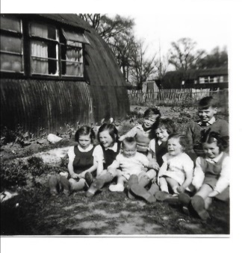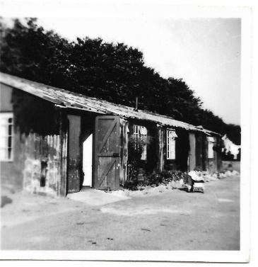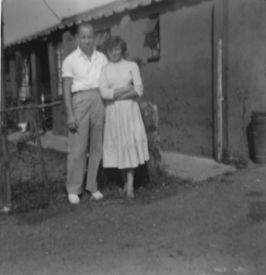

No 7 Corner Green
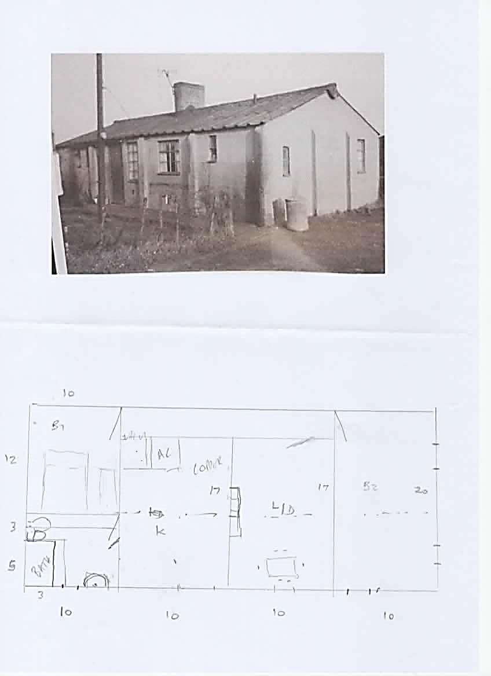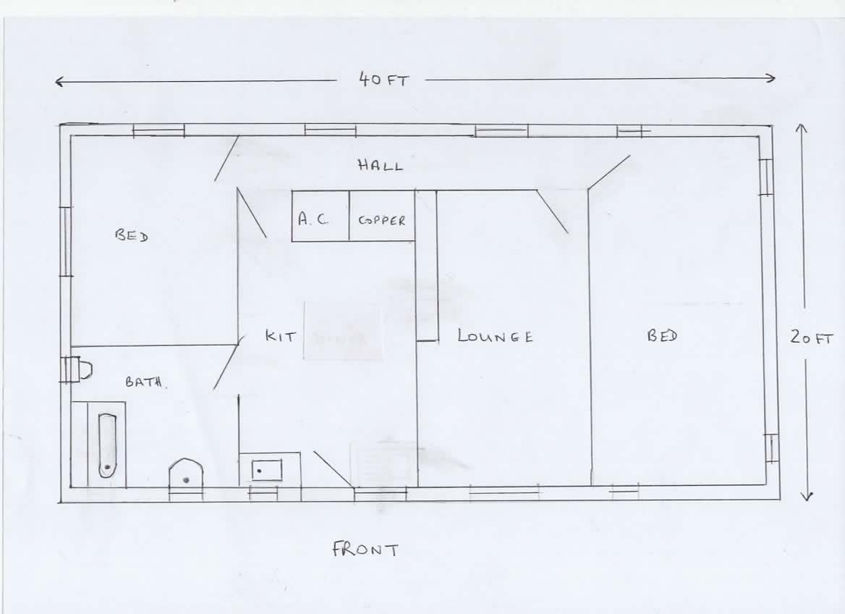
You will see from the plan above, drawn by Sandra, that they had all mod cons, a bathroom with hot and cold running water and sanitation, mains electricity, there was a kitchen with a brick ‘copper’ in the corner, heated by a small fire below, a sitting room with open fire and an oven over, although the oven was only used to create plant pots by melting old 78 records over a terracotta pot, which was then decorated. In fact many said that the living conditions at Corner Green were actually better than the facilities of some of the more substantial stone cottages in Collyweston itself which commonly had outside bucket toilets, emptied by the smelly wagon on a Monday.
Speaking to many of the ex residents of Corner Green it is clear that everyone has very strong and fond memories of the area, the children were safe, so long as they kept out of the air raid shelters and away from the Adders, everyone knew each other and all looked out for their neighbours.
Provisions arrived weekly courtesy of small holder and local grocer Arthur Scott in ‘Scotty’s green van’ (photo?). The rent man called once a month, fresh bread was delivered by Albert Blake, sadly no longer with us, who worked for the Bakery at King’s Cliffe. There was only one telephone on the site, situated at No 19, so any urgent calls for a GP etc had to be done courtesy of the residents there, who Sandra recalls being the Herbert family? The local GP, Dr Mackie would do his house calls on his horse, which he kept behind the surgery on St Mary’s Street in Stamford. One ex resident told us that Dr Mackie tied his horse to their fence, the horse feeling bored pulled the fence down much to the disgust of the patient’s mum! Another former resident reported that Dr Mackie asked her mum to hold his horse whilst he checked on his patient, and she refused!
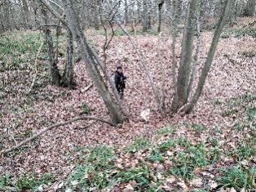
Trips to Stamford on the bus were considered an adventure. The children made paper boats to float down the endless streams which formed when it rained, they foraged in the nearby woods, got chased by the neighbours geese, rode up and down the very uneven track in the back of Sandra’s brother’s old black Austin A40 (which cost him the huge sum of £3!) used tin trays to slide down the “Hills and Hollows” in the woods. These were actually ‘sink holes’ which were formed at the end of the ice age by ice water draining away.

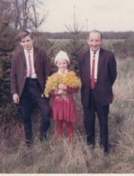
The family picked endless cowslips to make cowslip wine, went ‘wooding’ which was foraging for fallen branches for the fire, picked blackberries galore and generally made the best of it.

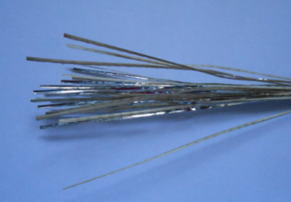
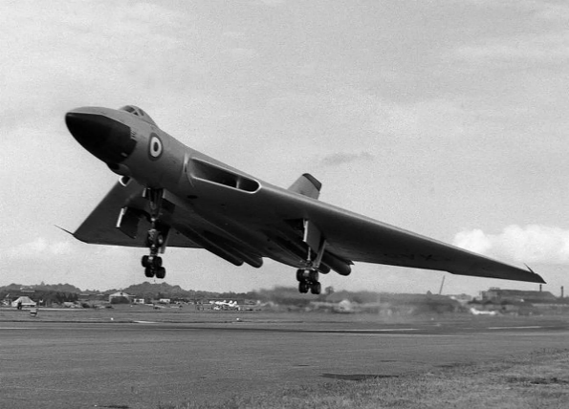
During the late 50’s early 60’s when the ‘Cold War’ was brewing, aircraft, presumably from Wittering, would drop silvery coloured strips, known as chaff, this was to block unfriendly radar seeking the site of the nuclear bomb store which was hidden deep in the woods! Sandra and her friends, taken with it’s shiny and ‘pretty’ appearance, used to collect it and take it home and used it to decorate their hair!! The families were well aware that they were sitting very close to nuclear weapons, but felt perfectly safe and pragmatic about their position, if a bomb was dropped on the store, they wouldn’t know anything about it – gone in seconds!! But it was undoubtedly a worrying time for the adults. The families would watch and hear the Vulcan bombers practice night flying and landing.

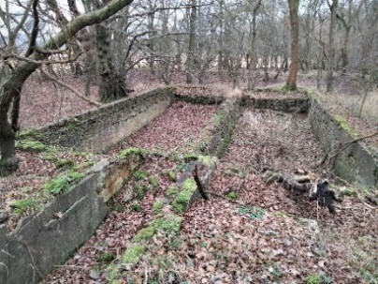
Sandra said she often got into trouble for playing ‘home making’ in the air raid shelters, others climbed the cast iron water tower on the edge of the wood, but as kids she and her contemporaries loved the freedom.
She would walk every day, or ride on the crossbar of her brother’s bike from ‘The Camp’ to the village school in Collyweston, in thunderstorms, snow and blazing sun, others would be put on the Eastern Counties bus and given pennies to pay for the bus fare for the return journey, young entrepreneurs would keep the pennies to buy sweets from Mrs Close at the Village Shop adjacent to the Garage (the White House next to Field Close) and walk back. It was a hard but very happy time of life. Being so close to nature the children grew up to respect, not only their elders but also the wildlife, fauna and floral of the area and the residents’ gardens were filled with vegetables and flowers. Swings and toys were made from wooden off cuts and much fun was had climbing and occasionally falling out of the trees in the woods whilst trying to see if the birds were nesting. Nothing was left to waste. ‘Scotty’ would collect food waste in large ‘pig’ bins to feed his pigs on his small holding in Collyweston.
Many of the mums took seasonal peace work on local farmer, Frank Gilman’s land, picking potatoes for the Golden Wonder crisp factory and, during the School holidays, the children would accompany them, some helped their mums pick while others played amongst the rows and sacks of potatoes. A favourite pastime was to find the biggest ‘spud’ they could, tie it on a long piece of string and hang it out the back of the open backed ‘jeep’ on their way home to see whose potato lasted the longest bouncing along the road. A little thing that brought much joy and took their minds of the freezing journey in the back of the jeep.
When the potato crop was finished, they would pick ‘stones’ on Mr Gilman’s racecourse and ride on the back of the open trailer, the health and safety squad would have gone crazy, but no one was hurt and everyone had a great time.
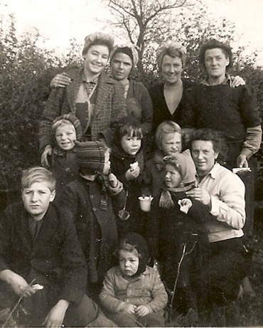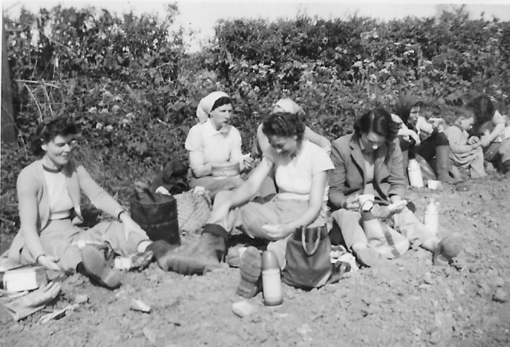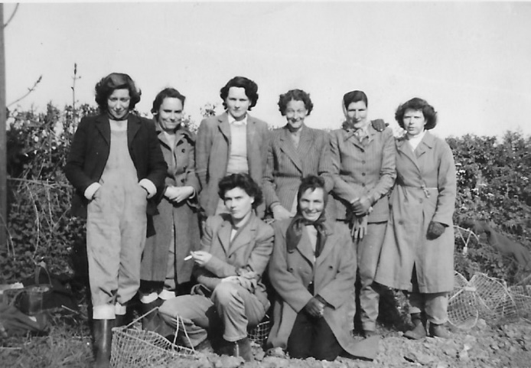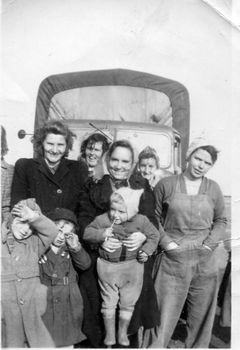

Sounds idyllic? Well it probably wasn’t for the adults but the children loved it and just occasionally we get the opportunity to remember and reminisce with former residents. Sandra was 7 when they finally moved into No 1 Westonville in 1962, shortly after they moved the site was leased to Bullimores for gravel extraction and was quarried out. Some of our older guests this evening may have a better recollection of life at Corner Green. Today we all live rather segregated and ‘private’ lives, but the memories remain of hardship, close friends and a very tight knit community. The residents and children truly ‘lived’ at Corner Green and are proud of it! Help us keep its memory alive and share your memories with us!
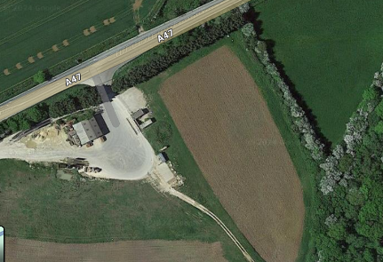
The site today.

HOW TIMES HAVE CHANGED!
The time we are talking about, 1950s, - 1960s, was so different to today (2024). No internet, no mobile phone, no Facebook or Twitter (X), black and white tv for some, most made their own entertainment with singing and dancing, playing cards or dominos. The wireless kept you in touch with events. Sandra recalls hiding from the rent man in the airing cupboard learning her times tables!
If you have memories of Corner Green you would like to share please do get in touch with either via this website or email collyhistory@outlook.com We look forward to hearing from you.

